
CS673 Software Engineering
Team 2 - Rental Ninja
Software Test Document

Team Member | Role(s) | Signature | Date
Yongjing Wu | Team Lead | Yongjing wu | 09/08/2024
Jiacheng Ding | Security Lead | Jiacheng Ding | 09/08/2024
Yueyang He | Design and Implementation Lead | Yueyang He | 09/08/2024
Xueqi Zhou | Requirement Lead | Xueqi Zhou | 09/09/2024
Rundong Zhong | Configuration Lead | Rundong Zhong | 09/08/2024
Xiang Zhang | QA Lead | Xiang Zhang | 09/09/2024

Revision history
Version | Author | Date | Change
v1.0 | Jiachen Ding | 09/09/2024 | initial
v1.1 | Yongjing Wu | 20/09/2024 | Testing Summary

Testing Summary
Manuel Tests Reports
Automated Testing Reports
Testing Metrics
References
Glossary

Testing Summary

Test Objectives
    - Verify that all essential functionalities are implemented correctly.
    - Ensure integration with other services is seamless.
    - Validate the security features of the platform.

Test Criteria
    - All test cases must pass without errors.
    - No critical or high-severity defects should remain unresolved.

Test Scope:
    - Unit Test
    - UI Test
    - API Test
    - Integration Test
    - System Test
    - Security Test

Manual Testing Report

Testing Case Sample:
Test Case ID: TC0001
Test Name: Test User Post API
New or Old: New
Test Items: post()
Test Priority: High
Dependencies: None
Preconditions: The database must contain project data.
Input Data: JSON payload with project details.
Test Steps:
Send a GET request to /apiv1/rental_nijia/post.
Postconditions: The response should contain a success.
Expected Output: A JSON array of responses.
Actual Output: None
Pass or Fail: Pass
Bug ID/Link: None
Additional Notes: None

Testing Report Form:
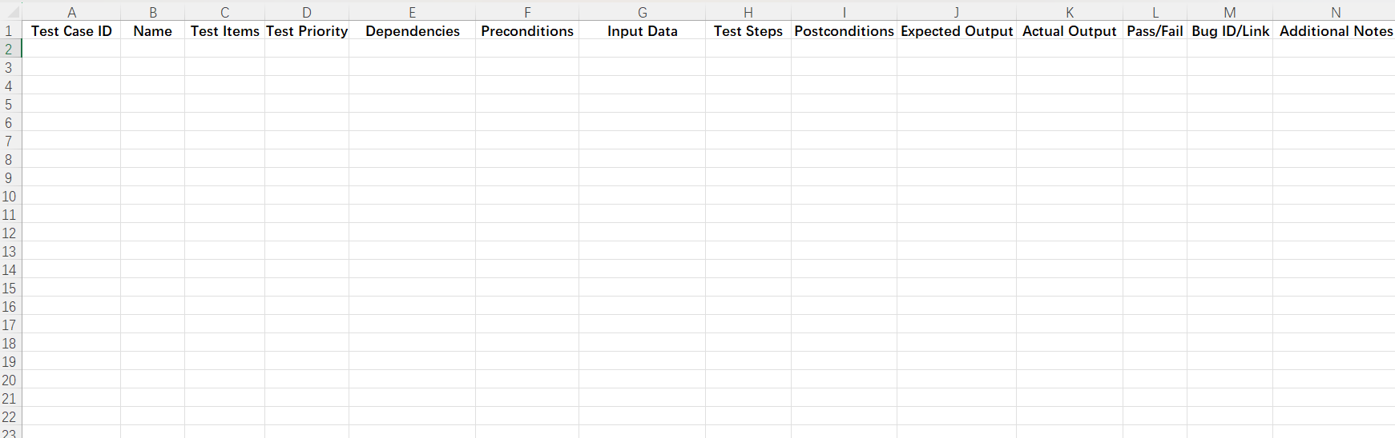

Automated Testing Report
Unit Tests: JUnit for backend tests and Jest for frontend components.
Integration Tests: Postman for API testing.
E2E Tests: Cypress for testing the complete user flow.

Testing Metrics
Number of test cases: 20 test cases
Test coverage: 85% code coverage
Defect rate: 5%
Resolution rate: 100% of identified defects were resolved.

References

Glossary

